**CS3377 Assignment 3**

**Question 1 – Earned Value Analysis**

Assessment of the Project

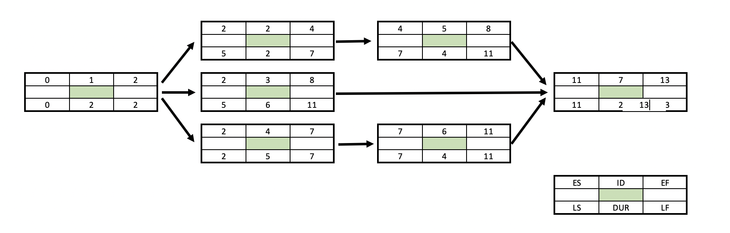

Earned Value (EV) = Percentage completion x Project baseline value

Cost Variance (CV) = Earned value(EV) – Actual Cost(AC)

Schedule Variance (SV) = Earned Value (EV) – PV

|  |  |  |  |  |  |  |
| --- | --- | --- | --- | --- | --- | --- |
| **Status Report: Ending Period 1** |  |  |  |  |  |  |
| **Task** | % Complete | EV | AC | PV | CV | SV |
| **1** | 50 | 500 | 500 | 1000 | 0 | -500 |
| **Cumulative Totals** |  | 500 | 500 | 1000 | 0 | -500 |
|  |  |  |  |  |  |  |

|  |  |  |  |  |  |  |
| --- | --- | --- | --- | --- | --- | --- |
| **Status Report: Ending Period 2** |  |  |  |  |  |  |
| **Task** | % Complete | EV | AC | PV | CV | SV |
| **1** | 90 | 1800 | 1500 | 2000 | 300 | -200 |
| **Cumulative Totals** |  | 1800 | 1500 | 2000 | 300 | -200 |
|  |  |  |  |  |  |  |

|  |  |  |  |  |  |  |
| --- | --- | --- | --- | --- | --- | --- |
| **Status Report: Ending Period 3** |  |  |  |  |  |  |
| **Task** | % Complete | EV | AC | PV | CV | SV |
| **1** | 100 | 2000 | 1500 | 2000 | 500 | 0 |
| **2** | 90 | 1440 | 0 | 1600 | 1440 | -160 |
| **3** | 5 | 25 | 200 | 500 | -175 | -475 |
| **4** | 30 | 300 | 500 | 1000 | -200 | -700 |
| **Cumulative Totals** |  | 3765 | 2200 | 5100 | 1565 | -1335 |
|  |  |  |  |  |  |  |

|  |  |  |  |  |  |  |
| --- | --- | --- | --- | --- | --- | --- |
| **Status Report: Ending Period 4** |  |  |  |  |  |  |
| **Task** | % Complete | EV | AC | PV | CV | SV |
| **1** | 100 | 2000 | 1500 | 2000 | 500 | 0 |
| **2** | 100 | 2400 | 1000 | 2400 | 1400 | 0 |
| **3** | 20 | 200 | 800 | 1000 | -600 | -800 |
| **4** | 60 | 1200 | 1500 | 2000 | -300 | -800 |
| **Cumulative Totals** |  | 5800 | 4800 | 7400 | 1000 | -1600 |
|  |  |  |  |  |  |  |

|  |  |  |  |  |  |  |
| --- | --- | --- | --- | --- | --- | --- |
| **Status Report: Ending Period 5** |  |  |  |  |  |  |
| **Task** | % Complete | EV | AC | PV | CV | SV |
| **1** | 100 | 2000 | 1500 | 2000 | 500 | 0 |
| **2** | 100 | 2400 | 2000 | 2400 | 400 | 0 |
| **3** | 30 | 600 | 800 | 2000 | -200 | -1400 |
| **4** | 65 | 1430 | 1500 | 2200 | -70 | -770 |
| **5** | 25 | 100 | 400 | 400 | -300 | -300 |
| **Cumulative Totals** |  | 6530 | 6200 | 9000 | 330 | -2570 |
|  |  |  |  |  |  |  |

|  |  |  |  |  |  |  |
| --- | --- | --- | --- | --- | --- | --- |
| **Status Report: Ending Period 5** |  |  |  |  |  |  |
| **Task** | % Complete | EV | AC | PV | CV | SV |
| **1** | 100 | 2000 | 1500 | 2000 | 500 | 0 |
| **2** | 100 | 2400 | 2000 | 2400 | 400 | 0 |
| **3** | 80 | 1840 | 2100 | 2300 | -260 | -460 |
| **4** | 85 | 2040 | 1800 | 2400 | 240 | -360 |
| **5** | 50 | 400 | 600 | 800 | -200 | -400 |
| **Cumulative Totals** |  | 8680 | 8000 | 9900 | 6800 | -1220 |
|  |  |  |  |  |  |  |

The indexes SPI, CPI, and PCIB are calculated using the following formulas:

Scheduling performance index (SPI) = EV/PV

Cost performance index (CPI) = EV/AC

Percent Complete Index (PCIB) = EV/BAC

|  |  |  |  |
| --- | --- | --- | --- |
| **Period** | **SPI** | **CPI** | **PCIB** |
| **1** | **0.5** | **1** | **0.034482** |
| **2** | **0.738235** | **1.2** | **0.124138** |
| **3** | **0.783784** | **1.711364** | **0.259655** |
| **4** | **0.783784** | **1.208333** | **0.4** |
| **5** | **0.725556** | **1.053226** | **0.450345** |
| **6** | **0.876768** | **1.085** | **0.598621** |

**What is the calculated length of the project?**

The length is 13 durations.

**Which activities are on the critical path?**

The critical path includes activities 1,4,6 and 7.

**Which activity is most sensitive?**

Activity 4 is the most sensitive due to it having the longest duration and no slack time which will increase project time length.

**Question 2 – Network Diagrams & PERT**

We are remodeling the Grad Club in Middlesex College. Some questions are being asked about our ability to possibly finish a bit early. Complete the analysis answering the questions below.

|  |  |  |  |  |  |  |  |
| --- | --- | --- | --- | --- | --- | --- | --- |
| Activity | Preceding activity | Best  A | Likely  M | Worst  B | Time est. (days)  tE =(A+(4M)+B)/6 | St. Dev  σte =(B-A)/6 | Variance  σte^2 |
| a. Rough in walls | - | 11 | 12 | 13 | 12.00 | 0.33 | 0.11 |
| b. Build the bar | a | 4 | 6 | 11 | 6.50 | 1.17 | 1.36 |
| c. run HVAC | - | 12 | 15 | 30 | 17.00 | 3.00 | 9.00 |
| d. rough in electrical | b,c | 12 | 15 | 20 | 15.33 | 1.33 | 1.78 |
| e. complete flooring | a | 7 | 12 | 22 | 12.83 | 2.50 | 6.25 |
| f. get licenses | e | 2 | 17 | 19 | 14.83 | 2.83 | 8.03 |
| g. install fire alarm | c,d,e | 13 | 17 | 19 | 16.67 | 1.00 | 1.00 |
| h. deliver kitchen equip | e,f | 9 | 14 | 19 | 14.00 | 1.67 | 2.78 |
| i. exposed ceiling reviews | c,g | 11 | 13 | 20 | 13.83 | 1.50 | 2.25 |
| j. build stage | g,h | 12 | 13 | 16 | 13.33 | 0.67 | 0.44 |
| k. sound system | j,i | 8 | 12 | 22 | 13.00 | 2.33 | 5.44 |

1. **Identify any redundant links still showing and cancel them**

By isolating the unique links, it is evident that the redundant links are c→g, c→i, and e→h.

1. **Identify the critical path**

The critical path is the path with the longest duration which is: a, e, f, h, j, k.

1. **Identify the slack for each element**

Slack is calculated as the difference between latest start and earliest start:

a = 0

b = 3.15

c = 4.65

d = 3.15

e = 0

f = 0

g = 3.15

h = 0

i = 19.32

j = 0

k = 0

1. **Identify the most and least sensitive element**

Most sensitive elements the ones with no slack which are the elements on the critical path: a, e, f, h, j, k.

Least sensitive element is the one with the most slack which is: i .

1. **Identify the predicted project duration (Total TE for critical path)**

TE = 12.00 + 12.83 + 14.83 + 14.00 + 13.33 + 13.00 = 79.99

Therefore, the predicted project duration is 79.99.

1. **Z is the probability of meeting schedule duration found in the statistical table below, and defined by the relationship:**

**Z = (Ts - TE) / SQRT(Σσte2 )**

**If Ts (Time scheduled) is 78 days, then what is the likelihood that we finish the project on time assuming TE is our predicted project duration? Express your response as a percentage chance.**

Given,

Ts = 78 days

TE = 79.99 days

Σσte2 = 0.332 + 2.502 + 2.832 + 1.672 + 0.672 + 2.332 = 23.03

Therefore we have,

Z = $\frac{(Ts - TE) }{√(Σσte2 }$

= $\frac{(78-79.99)}{√23.03}$

= -0.41

Therefore, the probability of meeting schedule duration is 41%.